Matchstick Equation

Problem description
Given n matchsticks, how many equations of the form “A+B=C” can you make? In the equation, A, B, and C are integers made out of matchsticks (if the number is not zero, the highest digit cannot be zero). The numbers 0-9 could be made with matchsticks as shown in the picture:
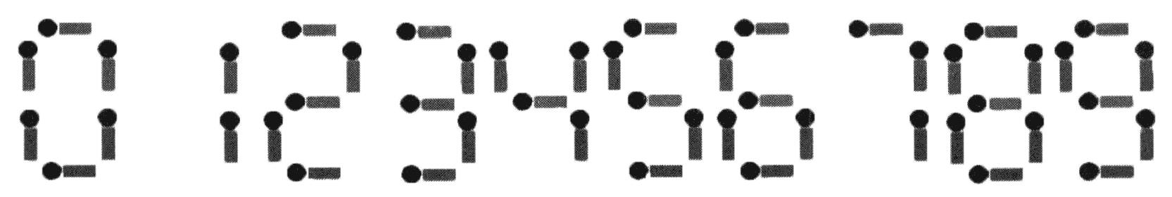
Note:
1. The plus sign and the equal sign each need two matchsticks.

2. If A≠B, then A+B=C and B+A=C are regarded as different equations (A, B, C ≥ 0).

3. All n matchsticks must be used.

Input
An integer n (1 ≤ n ≤ 24).

Output
The output file has one integer indicating the number of different equations that can be spelled.

Sample Input 1
14

Sample Output 1
2

Sample Input 2
18

Sample Output 2
9

Hint
[Explanation of Sample 1]
The two equations are 0+1=1 and 1+0=1.

[Explanation of Sample 2]
The 9 equations are:
0 + 4 = 4
0 + 11 = 11
1 + 10 = 11
2 + 2 = 4
2 + 7 = 9
4 + 0 = 4
7 + 2 = 9
10 + 1 = 11
11 + 0 = 11

